+
.

UNIPOWER LOGO

OPERATION MANUAL
THE 299 MULTIFUNCTION (115V AC)
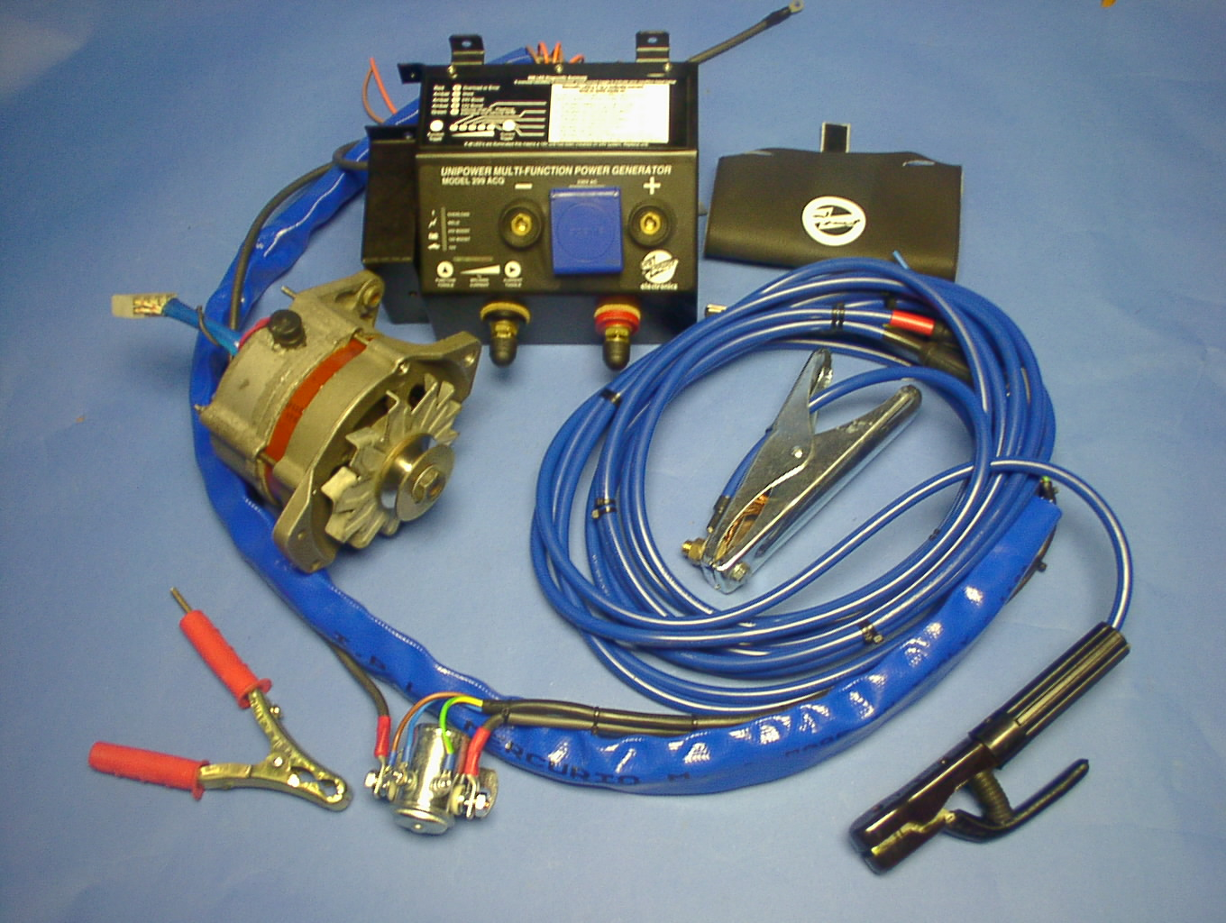

FORREST ENGINEERING SERVICES LIMITED
UNIT 100, MARCHINTON IND. EST.
STUBBY LANE
MARCHINGTON
STAFFORDSHIRE ST14 8LP
TELEPHONE 01283 821000
FAX 01283 82100. EMAIL sales@unipower-uk.biz

IMPORTANT SAFETY INSTRUCTIONS

SAVE THESE INSTRUCTIONS!

This manual contains important safety and operating instructions. Keep sealed and close to the product.

General Precautions

- Before using the UNIPOWER SYSTEM, read all instructions and cautionary markings on (1) the CONTROL MODULE (CM), (2) the installation manual and (3) all appropriate sections of this instruction manual.
- Do not expose the CM to rain, snow or liquids of any type. The CM is designed for interior mounting only. Protect the CM from splashing if used in vehicle applications where installations are made under the bonnet (hood).
- Do not disassemble the CM; take it to a UNIPOWER APPROVED service center whenever service or repair is required. Incorrect re-assembly may result in a risk of electric shock or fire. Unauthorized opening of the C M can result in the warranty becoming invalid.
- To reduce risk of electric shock, disconnect all wiring before attempting any maintenance or cleaning. Turning off the CM alone will not reduce this risk.
- NEVER quick-charge a frozen battery or damage to both pieces of equipment may result.
- No terminals or lugs are required for hook-up of the AC wiring. A direct socket outlet is supplies. Battery cables must be rated for 75ºC or higher and should be no less than 16mm². Crimped and sealed copper ring terminal lugs should be used to connect the battery cables to the DC terminals of the Alternator terminals; Soldered cable lugs are not acceptable.
- Torque all DC cable connections. Be extra cautious to reduce the risk of dropping a metal tool onto batteries as it could short-circuit the batteries or other electrical parts, resulting in sparks that, in turn, might cause an explosion.
- The following symbols are used in this manual and on the CM :
Chassis Earth
Battery
Phase
Inverter
=/~
AC Output
CM
Control
Module
- This CM is intended for use with a battery supply of either 12V or 24V DC. Make sure of the correct voltage of the model you have purchased. (Units are not interchangeable)
- Instructions for wall mounting: (See installation instruction manual.)
- Installing the alternator: (See installation manual).
- No DC disconnects are provided as an integral part of this Unipower Generator. DC disconnects must be provided as part of the system installation, if required.
- No over current protection for the AC output wiring is provided as an integral part of this inverter (CM). Over current protection of the AC output wiring must be provided as part of the system installation. See SYSTEM SAFETY WIRING REQUIREMENTS section of this manual.
- GROUNDING INSTRUCTIONS – This UNIPOWER SYSTEM (CM) should be connected to an earthed grounded, permanent wiring system. For most installations, the negative battery conductor should be bonded to the grounding system. Every installation should comply with all national and local, codes and ordinances.
- As a general rule – only use generator as secondary alternator in emergency vehicles and not as a replacement for the original alternator.

Personal Precautions

- Someone should be within range of your voice to come to your aid when you work near batteries.
- Have plenty of fresh water and soap nearby in case battery acid comes in contact with skin, clothing, or eyes.
- Wear complete eye protection and clothing protection. Avoid touching eyes while working near batteries. Wash your hands when finished.
- If battery acid contacts skin or clothing, wash immediately with soap and water. If acid enters eye, immediately flood eye with running cool water for at least 15 minutes and get medical attention immediately.
- Baking soda neutralizes lead acid battery electrolyte. Vinegar neutralizes spilled NiCad and NiFe battery electrolyte. Keep a supply on hand in the area of the batteries.
- NEVER smoke or allow a spark or flame in vicinity of a battery or generator
- Be extra cautious to reduce the risk of dropping a metal tool onto batteries. It could short-circuit the batteries or other electrical parts, which may result in a spark, which, in turn, might cause an explosion.
- Remove personal metal items such as rings, bracelets, necklaces, and watches when working with a battery. A battery can produce a short-circuit current high enough to weld a ring or similar to metal, causing severe burns.
- Be very careful when working with 115V AC output power.

Definitions

CM - The CM is the Control Module – The inverter circuitry is located within the control module. It is the CM because it controls the distribution and regulation of all circuits.

INTRODUCTION

Congratulations on your purchase of the UNIPOWER car unit - a piece of equipment that will offer you great versatility and a long life span. For optimizing both performance and reliability, follow the guidelines laid down in this manual.
Your new Unipower multifunction POWER SUPPLY is one of the most advanced types of Mechanical (alternator rotating energy) to AC Electrical Energy converters available today. It will give you years of reliable service in your vehicle, be it a purpose-built truck, boat, RV or service vehicle.
The 299 Multifunction unit is a microprocessor based and controlled unit.
The alternator needs to run to generate power. The Control Module (CM) rectifies and controls the output of the alternator.
The unit can be installed into either 12 or 24 Volt vehicle systems. The units are not interchangeable. Make sure you have the correct system voltage model before installing.
To get the most out of your Unipower generator, it must be installed and used properly, so please read the installation and operating instructions carefully before installing and using your Unipower generator. Pay special attention to the CAUTION and WARNING statements in this manual and those on the generator.

CAUTION: STATEMENTS THAT IDENTIFY CONDITIONS OR PRACTICES WHICH COULD RESULT IN DAMAGE TO YOUR CONVERTER OR TO OTHER EQUIPMENT.

WARNING: STATEMENTS THAT IDENTIFY CONDITIONS OR PRACTICES THAT COULD RESULT IN PERSONAL INJURY OR LOSS OF LIFE...

GENERAL WARNING: PLEASE REMEMBER THAT YOUR UNIPOWER GENERATOR PRODUCES HIGH VOLTAGES AND SHOULD BE TREATED ACCORDINGLY. ATTEMPTING TO CONNECT YOUR UNIPOWER GENERATOR TO DOMESTIC SWITCHBOARDS IS NOT RECOMMENDED AS POSSIBLE DAMAGE TO BOTH THE UNIT AND THE SWITCHBOARD MAY RESULT.

The UNIPOWER system is based around a heavy-duty, high speed, alternator that provides the power for the UNIPOWER system.
The 'heart' of the alternator - the stator, is specially hand wound to UNIPOWER specifications and ensures the multi-function capabilities of the unit.
The alternator is connected via a loom to the UNIPOWER control module (C.M.) , which regulates and distributes the current into one of 4 modes:

1. Charging the host vehicle’s battery (12V mode)
2. Boost charging and assist-starting 12V vehicle systems
3. Boost charging and assist-starting 24V vehicle systems
4. Welding and concurrent 115 V AC (or optional 110 volt) plug output.

The 115V AC output (during weld mode) is of modified Sine configuration (Quasi Sinewave) and is good for general use on loads such small motors, pumps and inductive loads.

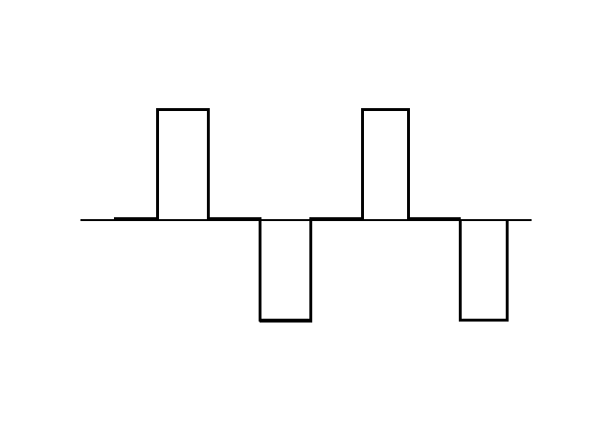
Figure 1: Modified SINEWAVE
The waveform is positioned somewhere between 'Chopped' DC and full SINEWAVE in output. It is ideal for recreational use in 4x4 vehicles, and for those customers wishing to run small compressors, variable speed equipment, electronic ballast fluorescent lights, microwaves, TV’s, videos, Hi-Fi systems, etc.

MODELS AVAILABLE IN RANGE AND DIFFERENCES

299-12V-Standard 12V Vehicles Only, Output is 115V AC up to 2.5KW, 50Hz, 12V, 12V boost, 24V boost and welding up to 175 Amperes, DC

299-12V-TURBO 12V Vehicles Only, Output is 115V AC up to 3KW, 50Hz, 12V, 12V boost, 24V boost and welding up to 225 Amperes, DC

299-24V-Standard 24V Vehicles Only, Output is 115V AC up to 2.5KW, 50Hz, 24V, 12V boost, 24V boost and welding up to 175 A DC

299-24V-TURBO 24V Vehicles Only, Output is 115V AC up to 3.0KW, 50Hz, 24V, 12V boost, 24V boost and welding up to 225 A DC

299-12V-Standard-115V 12V Vehicles Only, Output is 115 V AC up to 2KW, 50Hz, 12V, 12V boost, 24V boost and welding up to 175 A DC

299-12V-TURBO-115V 12V Vehicles Only, Output is 115 V AC up to 2.5 kW, 50Hz, 12V, 12V boost, 24V boost and welding up to 225 A DC 299 KIT COMPONENTS

THE UNIPOWER GENERATOR KIT COMPRISES 6 BASIC COMPONENTS:

- The Control Module
- The Loom (connecting the control module to the alternator).
- Welding cables and battery clamp
- Throttle Cable
- The Alternator
- Remote switch ( optional extra)

CONTROL MODULE

The control module (C.M.) is responsible for the regulation and distribution of the power produced by the Unipower alternator.
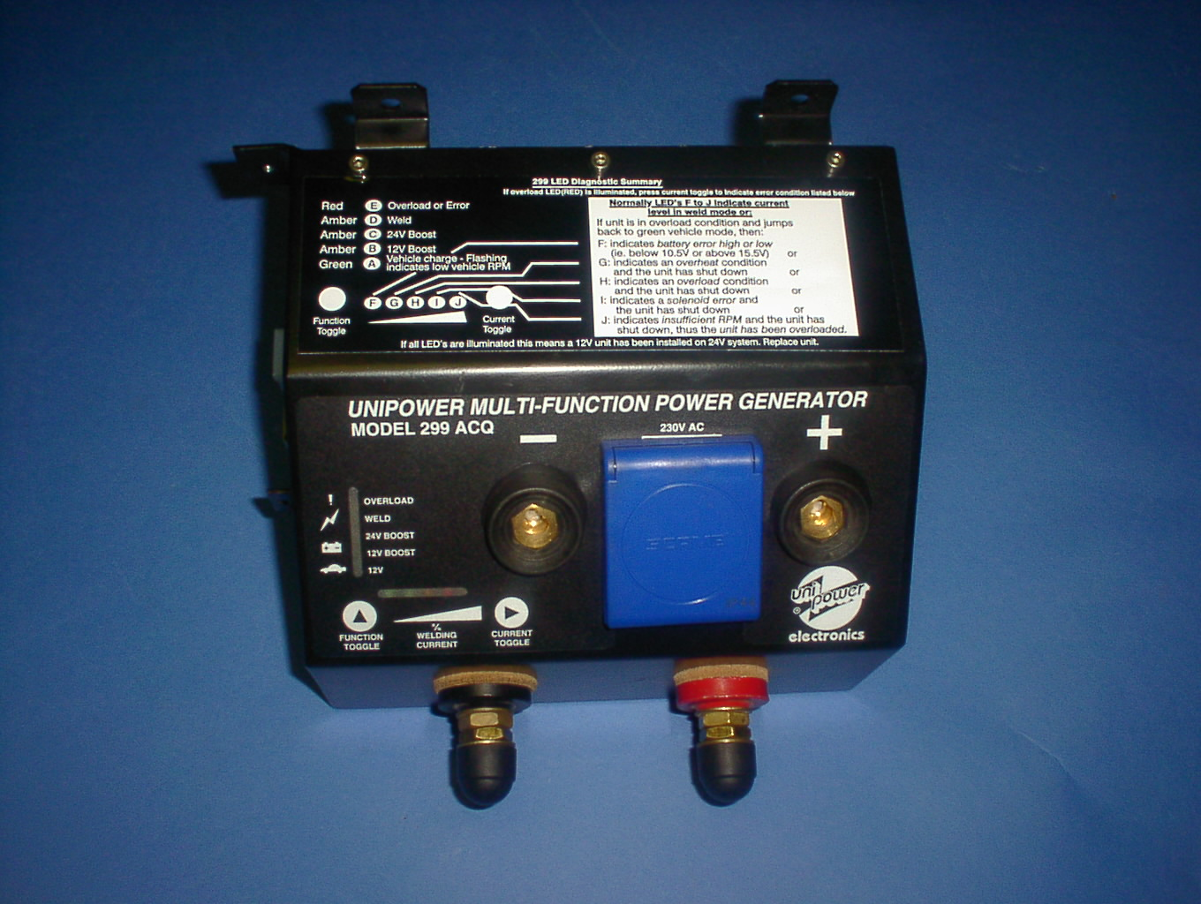
Figure 2 : 299 Control Module
Feedthrue Terminals
AC PLUG
Fixation Lugs and below error ind
Indications
Bayonet
Welding
Terminal
Mode setting/
Function Toggle
Weld
Current / Current toggle
Remote Connection/
9 Pin D sub
And connections

Unlike conventional alternators, the Unipower system regulates charge to the host vehicle's battery via the CM and not from the regulator affixed on the alternator. The regulator is disconnected and modified to Unipower specifications.
The Unipower is fitted with a function toggle mode selector and current toggle amp adjuster

Function Toggle

The function toggle button is used to toggle between the following modes. The new function is simply selecting by depressing the function toggle switch, the unit will jump to the next mode:
- 12V mode refer Paragraph 1.9.
- 12V Boost refer paragraph 1.10.
- 24V boost refer paragraph 1.11.
- Weld and 115V mode refer paragraph 1.12.

Current Toggle

The current toggle as displayed on the front panel is mainly used to select and set current limiting for welding (refer paragraph 1.12.2.1 ). The LEDs controlled by the Current toggle are also used to display all error conditions. (Refer to Error conditions and displays in Paragraph )

AC Voltage Socket Outlets

1 x 16A Schuckor plug for single-phase output. The rating of this plug is 16A and is not earthed.

Bayonet Welding terminals

Are for the connection of the cables for boost charging and welding functions.

Feed through Power terminals

The feeds through terminals carry the high current from the alternator to the welding terminals.

9 Pin Male D sub connector (on side)
This port is used to connect up the remote switch with the specific 9 pin cable supplied. This offers external control facilities.

9 Pin Female D-sub connector (on side)
This port is used for: Rev counter connections, control of external relays, or connection of external display meters. Please refer to installation manual for further details.

8 Pin connector on side for loom connection to Alternator
This point connects the loom, which in turn connects the Alternator to the CM.

Fixation Lugs

There are 4 mounting holes on the side plates of the CM. Mount the CM onto a flat surface. Use at least 6mm self-tapping screws to mount the CM. (Refer to Installation Manual).

Figure 3 Unipower 299 Complete Kit

Loom: (consolidated Cable)

Carries the current from the alternator into the Control Module. Standard Loom length is 1.5m. Extensions are available on request. This connects the CM. to the alternator and has a solenoid as an integral part of its assembly. All connectors are crimped and soldered for extra durability.

Welding Cables
Cable with electrode holder
- Cable with negative clamp
- Positive clamp for battery charging (dedicated positive leads are also available
On request)
Standard cable is 16 mm and green in colour.
Turbo cable is 25 mm and blue in colour.

The Throttle cable

Constructed of heavy-duty, rack and pinion design, the usual cable length is 1.20 meters but extensions are available on request.

Alternator

UNIPOWER employ only internationally-recognized alternators which are famous for their heavy-duty construction, long life, adaptability and internationally-available spares support.
The alternator is modified in several aspects from its original state:
A. Special heavy-duty, hand-wound stator.
B. Modified (re-enforced) diode plate.
C. Special pulleys, which maximize belt grip.
The alternator can be supplied in many different forms to suit the various vehicle configurations
That make up the international markets. Twin leg and single leg configuration are available.
A Unipower modification to a Nippon-Denso pump-alternator is also available for specialized
Applications.
When ordering your UNIPOWER kit make sure that you are aware of the vehicle onto which
The UNIPOWER car unit is going to be installed, as it will make the installation that much easier.
The UNIPOWER alternator can be adapted for marine use or for work in areas of very high
Temperatures. For further information, contact your local dealer.

Remote Switch (Optional Extra)
The remote switch is an optional extra accessory. It can be used to control the 299 from a predetermined distance (according to cable length). Cables available are 1.5M, 3M and 5 M.

All functions and displays available on the 299 CM are also available on the remote switch.
Control
Module
Remote
Switch
9 Pin D sub
Connector
On side of
CM

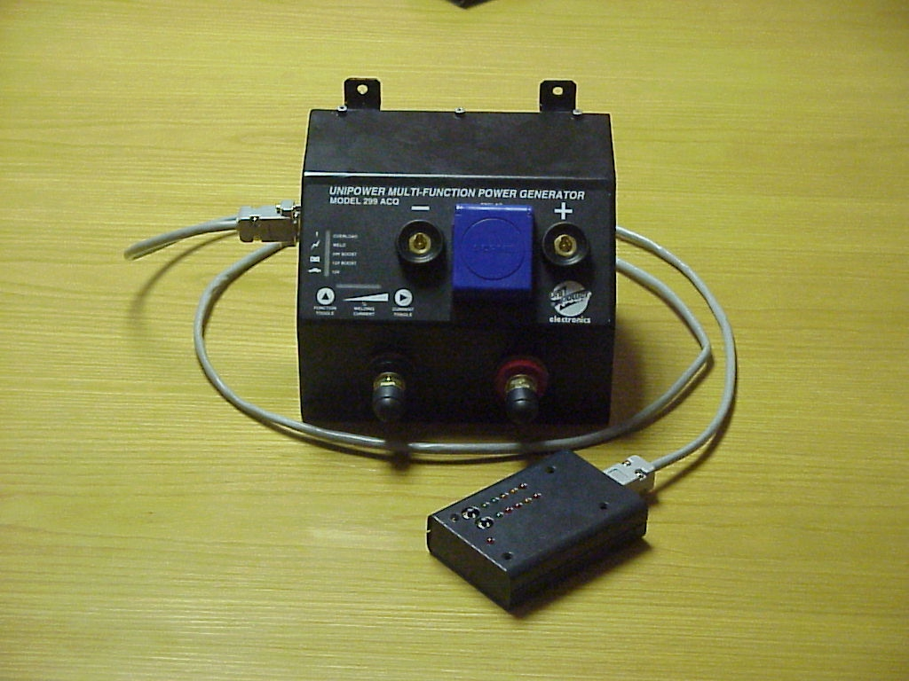
Figure 4 Remote switch connected to 299

PRINCIPLES OF OPERATION

Switching on the 299 when used as main (original) alternator.

After successful installation (installation manual). The 299 should light up when the vehicle is switched on. The unit is then, by default, in 12V-charge mode and ready for use. In this mode the battery voltage should now be charging at 14.1V (28,2V for 24V).

Switching on the 299 when used a double-up system.

As per installation manual, the unit should/will have an in-line switch situated between the CM and the battery, via the brown wire. By turning the inline switch on, the unit will be activated, the 12V mode light should illuminate and the unit is then ready for use.
NOTE: THE 299 WILL INDICATE AN ERROR CONDITION IN THIS MODE AND WILL DISABLE THE 12V MODE FUNCTION – THIS IN NORMAL FOR DOUBLE UP INSTILLATIONS.

12V MODE:

The first green LED next to the 12V indicator on the front panel is illuminated. Refer to Figure 5. If the vehicle (299) is switched off, it will automatically default back to this mode of operation. If any error condition occurs the unit will also revert back to this mode of operation.

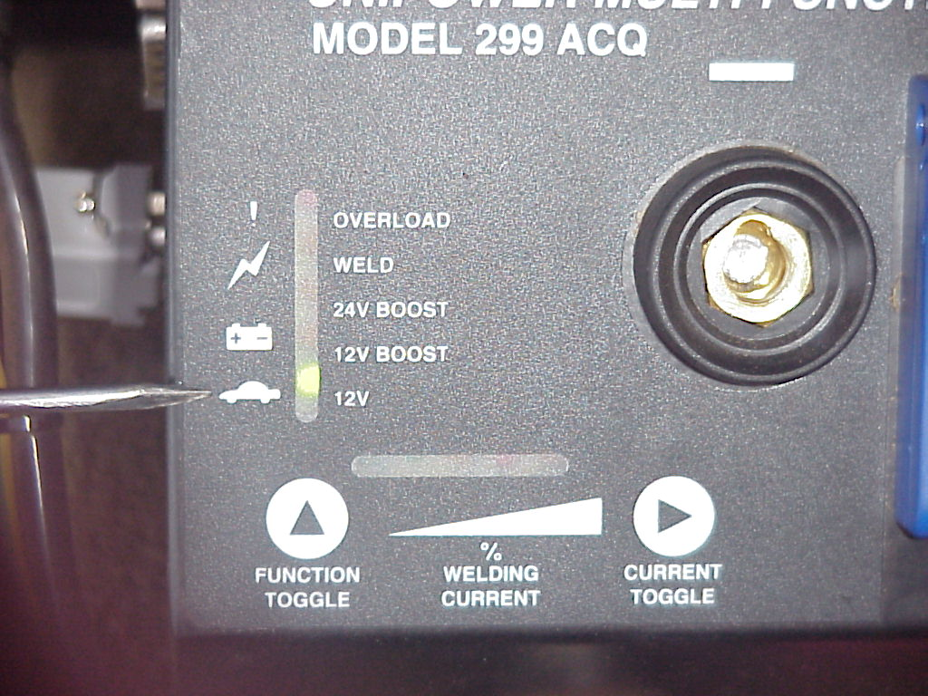
Figure 5 : 12V Mode display

In this mode of operation, the 299-model will charge your (Host) vehicle battery - like a normal alternator. The regulation voltage is set at 14.1V +- 5%. The voltage however can be increased for Nordic or cold countries if/when required.

CAUTION: THE MODE IS INTENDED FOR VEHICLE CHARGING DO NOT USE OR LEAVE 115V APPLIANCES ATTACHED TO SOCKET OUTLET.

NOTE: IN SYSTEMS WHERE THE 299 IS USED AS A DOUBLE UP, THIS MODE OP OPERATION IS USUALLY NOT REQUIRED AND IS DISABLED – AN ERROR LIGHT WILL DISPLAY, WHICH IS NORMAL.

12V BOOST MODE;

In this mode of operation, the host vehicle's battery is disconnected from the charging alternator. The voltage is set at 16V (+- 5%) and is measured across the POSITIVE (+) and NEGATIVE (-) Terminals of the 299 CM. Battery or boost charging to another vehicle's battery is done by using the welding cables and the extra battery clamp supplies as per Figure 3 & Figure 6. The UNIPOWER automatically compensates an increase of battery voltage by adjusting the battery current- this obviates overheating the battery plates.
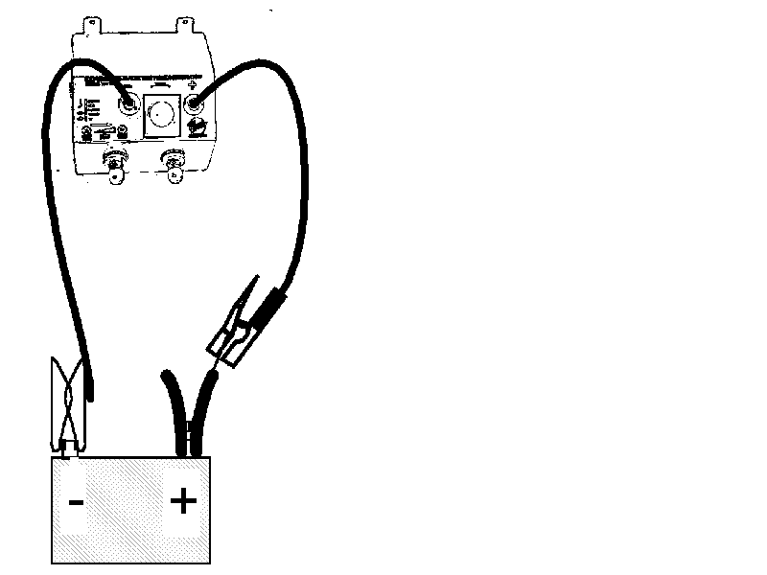
Figure 7 : Connections for 12V Boost
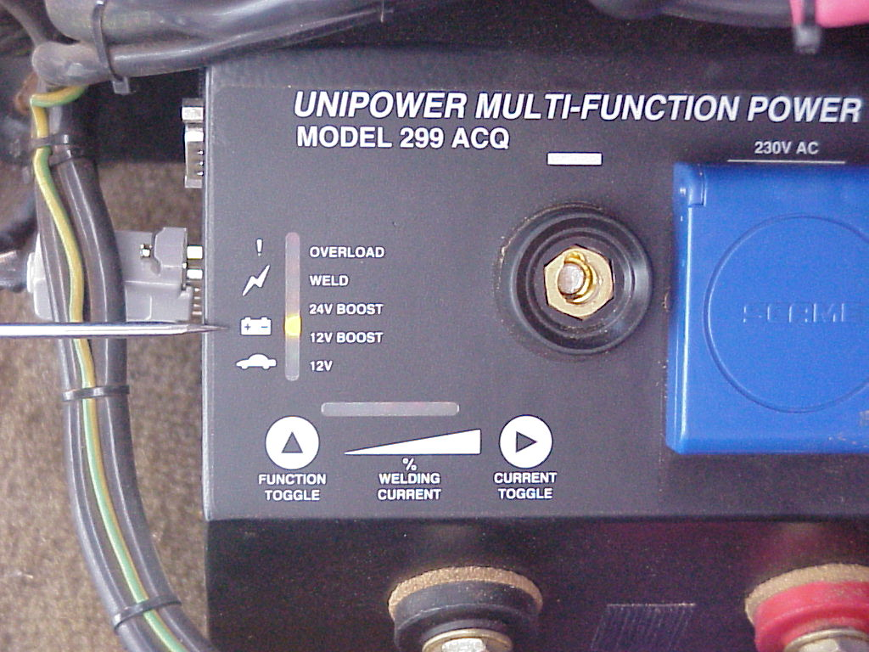
Figure 6 : 12V Boost mode

CAUTION: THE MODE IS INTENDED FOR VEHICLE BOOST CHARGING ONLY. DO NOT ATTEMPT TO USE OR LEAVE 115V APPLIANCES ATTACHED TO SOCKET OUTLET DURING OPERATION IN THIS MODE.

BOOST CHARGING - GENERAL HINTS
Your unit is fitted with a 12 and 24 volt Boost mode on the switch. Increasing your engine RPM will only increase your amperage, as your voltage is regulated (16 and 30 volts respectively). This prevents over-voltage charging which could damage your battery.
A. Boost charging, or fast charging as it is sometimes called, is acceptable if your battery is in good condition. As a guide, fast charging would increase a 12 volt battery’s voltage to about 16 volts - more than this simply increases the battery’s temperature and causes excessive gassing without accepting any more charge. If the battery exceeds 50 degrees Celsius, damage to the plates will start to occur. So when boost charging, keep it short - say 5 minutes to be on the safe side.

CAUTION: CERTAIN LEISURE AND GEL BATTERIES ARE NOT SUITED TO FAST CHARGING. IN THIS INSTANCE THE ORDINARY “CAR” POSITION MAY BE MORE SUITABLE FOR CHARGING UP THE BATTERY.

B. The welding leads can double as Boost Charging leads by connecting the battery clamp, inserted in the electrode holder, to the positive battery terminal and the earth terminal to the negative terminal. It is now possible to fast charge other batteries either in or out of another vehicle and/or quickly assist start any vehicle (with a flat battery be it 12 or 24 volt system).
If the UNIPOWER is required to do regular heavy-duty battery charging, it is advisable to purchase a dedicated positive cable and clamp (available from the manufacturer or your dealer).

BOOST CHARGING AND ASSIST STARTING

A. 12 VOLT VEHICLES

- Select 12-Volt Boost position with engine idling.
- Using the UNIPOWER weld/charge cables and positive clamp accessory, connect these to the positive and negative terminals of the third Party’s battery.
- Then connect the negative cable to the UNIPOWER control module's negative terminal and finally the positive to the Unipower positive terminal.
- Increase the engine speed to about 2,000-RPM and allow it to run for 2 - 3 minutes.
- With your engine still running, attempt to start the disabled vehicle (it usually starts almost straight away - unless it has a fuel or ignition problem). If not, run for a few more minutes and try again. This not only charges up the disabled vehicle’s battery but also increases the starting voltage by about 15 %, which gives it a lot more starting power. When it starts, reduce your engine to idle and then remove the cables from the module.
WARNING: NEVER REMOVE CABLES FROM THE BATTERY WHILST ENGINE IS STILL REVVING – THIS COULD CAUSE SPARKS WHICH COULD IGNITE BATTERY GASES (HYDROGEN) AND CAUSE AN EXPLOSION.

CAUTION: DON’T CRANK THE DISABLED VEHICLE FOR LONG PERIODS. IF IT WON’T START AFTER TWO OR THREE SHORT ATTEMPTS, THERE IS PROBABLY SOMETHING ELSE WRONG e.g. FAULTY BATTERY (DEAD CELL, DRY CELLS etc.)

24V BOOST MODE;

In this mode of operation, the host vehicle's battery is disconnected from the charging alternator. The voltage is set at 30V (+- 5%) and is measured across the +- Terminals of the 299-CM. Using the welding cables and the extra battery clamp supplied as per Figure 8 & 9.

NOTE: THE MODE IS INTENDED FOR VEHICLE CHARGING DO NOT USE OR LEAVE 115V APPLIANCES ATTACHED TO SOCKET OUTLET.
. 24 VOLT VEHICLES

- Select 24-Volt Boost position with engine idling. Attach leads as described in Paragraph 1.10.1
- Engine revs can be increased to 3,500 RPM for 2 - 3 minutes.
- Attempt to start the disabled vehicle
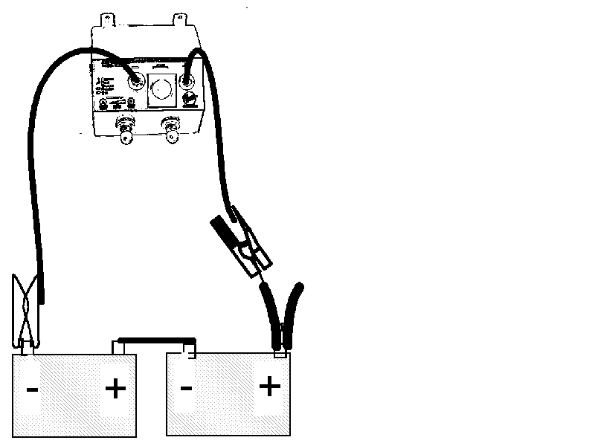
Figure 8 : 24V Boost charging

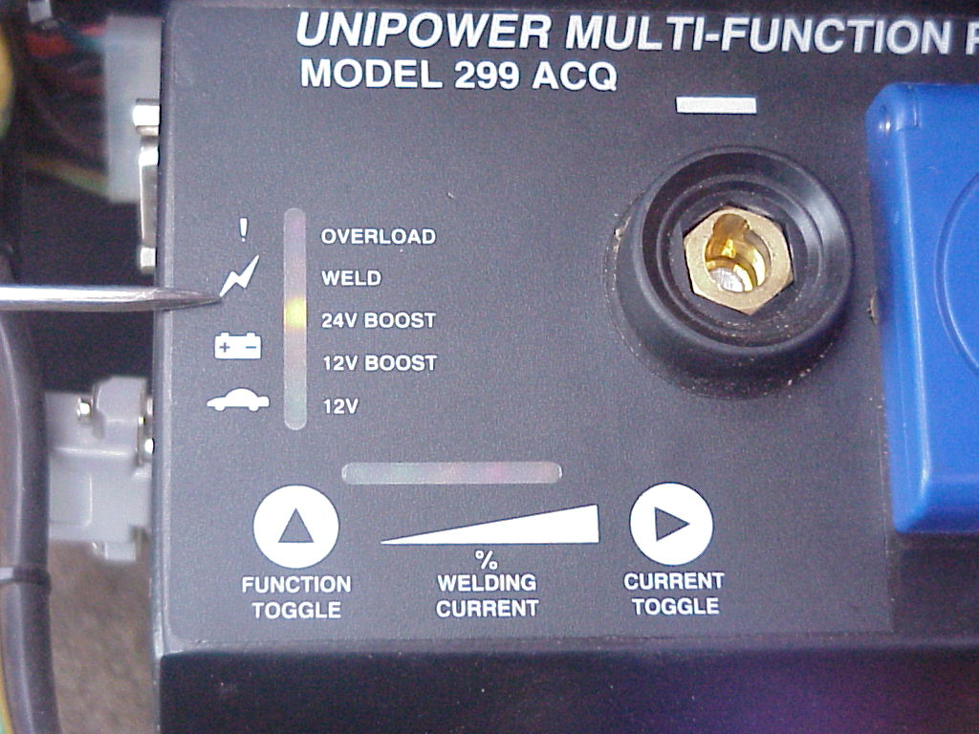
Figure 9 : 24V Boost mode

WARNING: IN THE EVENT OF THE HOST VEHICLE’S ENGINE STALLING WHILST ATTEMPTING TO BOOST CHARGE, DISCONNECT THE POSITIVE CLAMP FROM THE UNIPOWER CONTROL MODULE AND SWITCH BACK TO 24V BOOST POSITION PRIOR TO RECOMMENCING BOOST CHARGING. FAILURE TO FOLLOW THIS PROCEDURE MAY LEAD TO DAMAGE TO YOUR UNIPOWER AND THE WARRANTEE DOES NOT COVER THIS DAMAGE!

WELD AND 115V AC MODE

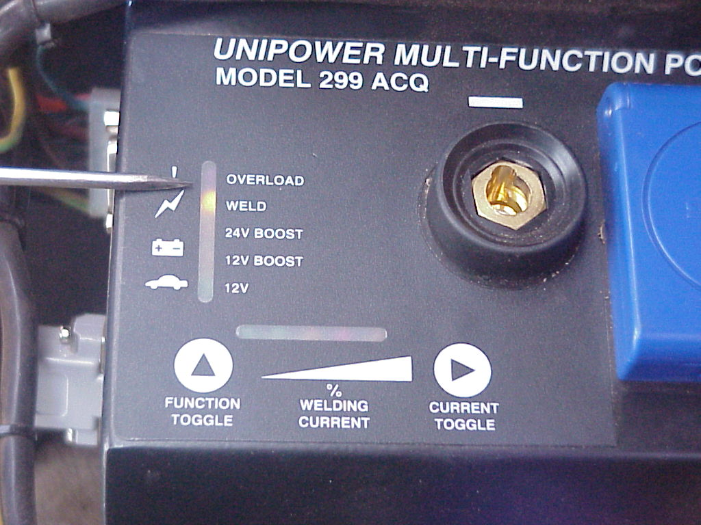
Figure 10 : Weld position
Weld mode is the last and fourth mode of operation. In this mode the welding as well s the 115V is activated

In this mode of operation the current limiting is automatically set in the unlimited position.
The 115V AC is now activated and functional. If the RPM is too low for 115V to be functional, the 12V light will be flickering, indicating low RPM. Increase RPM to reach workable condition. .
The welding OCV is set at 50V DC. You are now able to undertake DC welding as well as use 115V AC appliances. However, Unipower recommends that no load in excess of 500W be employed whilst welding.

Welding

- Connect weld cables to control module. (If ordinary welding is required) negative to negative, positive to positive. (If reverse polarity is required) connect negative to positive, positive to negative.
- Insert welding rod required into electrode holder provided. Connect negative clamp to material to be welded. Ensure the rod is designed for positive polarity (usually indicated by a RED band around the electrode).
- Increase vehicle RPM from 2,500 (12 Gauge) to 3,000 (8 Gauge). The RPM may be slightly lower or higher depending on the ratio between the vehicle's crankshaft and alternator pulley and on the type of Unipower model being employed (Standard or Turbo).
- On completion, reduce engine RPM and disconnect cables. Return to 'car' position.

NOTE: IF THE INSTALLATION IS A REPLACEMENT OF THE ORIGINAL ALTERNATOR THEN, WHEN WELDING FOR LONG PERIODS, IT IS ADVISABLE TO TURN THE UNIPOWER BACK TO “CAR” CHARGING MODE EVERY 30 MINUTES OR SO. THIS ALLOWS THE BATTERY TO REGAIN LOST CHARGE CAUSED BY THE OPERATION OF THE IGNITION, THERMO FAN, and RADIO etc. WHILST IN WELDING MODE

Principles of DC Welding:

High frequency DC welding is generally accepted as being superior to AC welding, attributable to the high alternator RPM and the rectification of the multiple pole, 3phase system
(AC to DC) The frequency is 20 times higher than that of conventional 50 Hz DCc welders.

This system produces a unique and desirable type of DC welding output. It consists primarily of straight direct current, with approximately. A 10A superimposed high frequency ripple current component. The ripple has the affect establishing and maintaining the arc more easily and more smoothly than its open voltage value would suggest. This system thus permits a more versatile ROD range for DC welding, including:

UNIPOWER ARC WELDING PROCESS | Abbreviation | Remarks
Manual Metal Arc Welding | MMAW | Wide range of electrode types and sizes ( low hydrogen electrodes to 4mm (8 s.w.g)
Gas Metal Arc Welding | GMAW or Mig OR CO2 Welding | MIG accessories required. Most applications can be configured for constant voltage output performance
Gas Tungsten Arc Welding | GTAW or TIG | TIG accessories required. High frequency DC applications
Flux Cored Arc welding  - With Gas shield  - Without gas shield | FCAW | FCAW accessories required. Excellent performance with self shielded wires up to 1.6mm (16s.w.g.) in diameter
Submerged Arc Welding | SAW | SAW accessories required. Units can be connected in parallel for the desired performance
Carbon-arc Air cutting or Gouging | AAC or AAG | Carbon-arc Air accessories required. Limited to 4mm diameter carbon electrodes. Some applications may require voltage boosting.

NOTE: WELDING RATING IS CONTINUOUS FOR 10 MINUTES ON ALL WELDING APPLICATIONS. (I.e. 100% Duty Cycle).

WELDING LIMIT SETTINGS

The 299 offers a welding current control function. At default the unit is in the unlimited position it is also possible to see the value of the weld current as the bar chart will display the current value up to its optimum position.

By pressing the amperage-adjusting toggle switch the adjusting facility is activated. An LED will light up indicating the current setting value. By pressing the switch again, the displayed LED will jump to the next value.

NOTE: THE AMPERAGE ADJUSTMENT FUNCTION IS NOT A DIRECT LINEAR FUNCTION AND THERE IS THUS NO DIFFERENCE BETWEEN THE STANDARD AND TURBO UNITS

OPERATION ON THE AC PLUG.

The alternator is double wound to give simultaneous Welding and AC Plug output. The power output produced is a function of alternator RPM.

CAUTION: WHILE WELDING DO NOT LOAD AC OUTPUT WITH MORE THAN 500W OR STATOR DAMAGE COULD OCCUR

The alternator produces a high frequency, high voltage 3 phase AC, which is rectified and controlled with a 3phase Thyristor and diode bridge. This, in turn, produces a DC bus voltage of approx. 265 V DC. This high voltage DC is then inverted by a full bridge IGBT inverter to convert the DC to AC.

NOTE: THE 115V AC IS NOT EARTH FAULT PROTECTED. EXTERNAL EARTH FAULT PROTECTION IS REQUIRED - IF SUGGESTED OR REQUIERED BY LOCAL GOVERNING BODY

NOTE: 115V AC IS MODIFIED SINEWAVE AND NOT PURE SINEWAVE. IT THEREFORE LIMITs THE LOADS ONE CAN USE ON IT. IN GENERAL, IT CAN RUN UP TO 95 % OF ALL KNOWN LOADS, CAPACITIVE LOADS ARE LIMITED AS WELL AS SOME COMPRESSORS. CONTACT YOUR SUPPLIER FOR MORE INFORMATION.

NOTE: DUE TO POWER RATING AND THE WIDE DIVERSITY ON STARTUP CHARACTERISTICS OF COMPRESSORS, THE UNIT IS NOT ALWAYS ABLE OF RUNNING ALL COMPRESSORS WITHIN IT’S RATINGS. THE MAXIMUM SUGGESTED SIZE OF COMPRESSOR TO USE IS UP TO 1100W OR AS GENERAL RULE, UNITS WITH A STARTUP CURRENT NOT EXCEEDING 20-25A.

NOTE: POWER IS SUPPLIED BETWEEN LIVE AND NEUTRAL PINS ON THE AC PLUG OUTLET; IT IS ALSO PROTECTED FOR OVERLOAD AND SHORT CIRCUIT CONDITIONS. IT IS, HOWEVER, POSSIBLE TO DAMAGE THE UNIT IF AC IS SHORTED TO VEHICLE CHASSIS OR GROUND. THIS DAMAGE IS NOT COVERED BY WARRENTY. ENSURE LOADS USED are FREE OF EARTH FAULTS.

The voltage output of 299 does fluctuate; this is a function of alternator RPM well as loads used and subsequent regulation. The RMS value would, however, stay within parameters which are 115V AC +- 10%. This is equivalent to the supply offered by Power distribution networks. The frequency is crystal-controlled to 50 Hz +-1%.

PROTECTION OFFERED IN THE 299 MULTIFUNCTION UNIT.

The 299 unit offer various ways of overload and system protection.

- Short circuit protection on 115V AC - The 299 offers full short circuit protection between Live and neutral outputs. When the output is short-circuited the unit will display overload and jump back to 12V mode. The 115V AC will then be disabled. (FOR ERROR DISPLAY indication SEE PARAGRAPH 1.14. )
- Continuous overload on 115VAC – The 299 offers a continuous overload setting which is set at 13-15A. This is equivalent to 3- 3.5kVa on the plug output. If the continuous plug rating exceeds this, the 299 will indicate overload and return to the 12V mode. The overload light will flash indicating an overload condition has occurred. (FOR ERROR DISPLAY INDICATION SEE PARAGRAPH 1.14. )
- Thermal overload – The 299 is thermally protected. If the unit operates in a VERY HOT environment or continuously at optimal load (3-3.5kW), the unit will (could) go into thermal overload. In this condition the unit's internal temperature will have exceeded 80C. The unit will then shutdown, return to 12V mode and continue to charge the (host) battery only. The overload light will illuminate and, if one depresses the function mode selector, the 2 nd light from the left will indicate the thermal overload condition. Depending on the environmental temperature, the unit could take between 10 and 50 minutes to cool down before it is functional again. (FOR ERROR DISPLAY INDICATION SEE Paragraph )

NOTE: TO ENABLE LONG WORKING PERIODS AT HIGH POWER LEVELS, ALWAYS ENSURE SUFFICIENT COOLING. IF CONTINUOUS OPERATING LOADS OF 2-3 KW ARE REQUIRED, IT IS SUGGESTED THAT A FAN BE ADDED TO THE 299 UNIT. CONTACT YOUR SUPPLIER FOR FURTHER DETAILS.

d) Alternator protection – As the alternator is the main power conversion source, most of the heat is generator in this area. It is very important for the longevity of the alternator stator that it is sufficiently cooled. The 299 CM will continuously “refer” to see if the power drawn from the alternator is exceeding the “safe operating” condition of the alternator. If the load applied is drawing power from the CM, and this exceeds the rating, the 12V LED on the CM will flash, indicating a request to “INCREASE RPM”. However, if the unit is loaded without increasing the RPM, the unit will go into overload, (even if just 1 kW is applied as a load.) The 299 does allow a period of up to 30 seconds before going into overload condition. (This period is to allow for the start-up power required for motors, etc). In this condition the unit will display 'overload', the 12V, 12V boost light will all be illuminated. To reset the unit, press the function mode selector

NOTE: FOR POWER REQUIREMENTS BETWEEN 2 – 3 Kw, IT IS IMPORTANT TO MAKE SURE THAT THE ALTERNATOR ROTATES BETWEEN 6,000 AND 8,000 RPM.

.

299 LED DISPLAY (WORKING AND ERROR CONDITIONS)

DISPLAY BY LED NUMBER
Figure 11 : LED Display by Number

- When the 299 unit is activated, the 12V mode LED A (green LED) will light up. This is a default position. In the weld mode this LED is also used to display low RPM. When this LED flashes, the alternator is either not turning or the RPM is too low for the alternator to handle the power.
- 12V boost mode, Amber LED B. This LED lights up in this mode of operation
- 24V Boost mode , Amber LED C, this led will light up in this mode of operation
- Weld mode, Amber LED D, this led will light up in this mode of operation.
- Overload, Red LED E. In any error condition, this LED lights up. With various error conditions this LED will indicate differently.E.G. A short circuit condition will keep the light on permanently. Continuous overload will show flashing LED.
- Green LED F is used differently in different modes. During weld mode, it would only be on, when a weld current is present. It will also be used for current setting. Should the overload light be on and unit jumps back to 12V mode. One can depress the current toggle selector, which will then indicate the cause of the error. If this LED is on, it means battery error. Battery error means that either battery voltage is too low ( below 10.5V or battery above 15.5V)
- Green LED G is used differently in various modes. During weld mode, it would only be on, when a weld current is present. It will also be used for current setting. Should the overload light be on and unit jumps back to 12V mode then one can depress the current toggle selector, which will then indicate the cause of the error. If this LED is on, it means the unit has shutdown due to an overheat condition.
- Amber LED H is also used differently in various modes. During weld mode, it would only be on, when a weld current is present. It will also be used for current setting. Should the overload light be on and unit jumps back to 12V mode one can depress the current toggle selector, which will then indicate the cause of the error. If this LED is on, it means the unit has shutdown due to an overload condition.
- Amber LED I is used differently in various modes. During weld mode, it would only be on, when a weld current is present. It will also be used for current setting. Should the overload light be on and unit jumps back to 12V mode one can depress the current toggle selector, which will then indicate the cause of the error. If this LED is on, it means the unit has shutdown due to a Solenoid error. Solenoid error is either caused by the voltage drop between the battery and alternator is exceeding 1V in 12V mode (which could be fire hazard), or in other modes, the solenoid did not open up (Burnt). CHECK YOUR SOLENOID.
- Amber red LED J is used differently in various modes. During weld mode, it would only be on, when a weld current is present. It will also be used for current setting. Should the overload light be on and unit jumps back to 12V mode one can depress the current toggle selector, which will then indicate the cause of the error. If this LED is on, it means the unit has shutdown due to a LOW RPM AND OVERLOAD condition.
K) All LED’s light up - 12 V unit has been installed into 24V vehicle, replace unit.

APPLICATIONS

NOTE: EXAMPLES AND DESCRIPTIONS OFFERED BELOW ARE ILLUSTRATIVE
ONLY.

RESISTIVE LOADS

These are the loads that the inverter finds the simplest and most efficient to drive. Voltage and current are in phase or, in this case, in step with one another. Resistive loads usually generate heat in order to accomplish their tasks. Toaster, coffee pots and incandescent light are typical resistive loads.

INDUCTIVE LOADS

Any device that has a coil of wire in it probably has an inductive load characteristic. Most electronic devices have transformers (TV’s, stereos, etc) and are therefore inductive. Typically, the most common inductive loads are motors. The most difficult load for the Unipower to drive will be the largest motor you could manage to start. With inductive loads, the rise in voltage applied to the load is not accompanied by a simultaneous rise in current. The current is therefore delayed. The length of the delay is a measure of inductance. The current makes up for its slow start by continuing to flow after the inverter changes AC voltage polarity.

Inductive loads, by their nature, require more current to operate than a resistive load of the same wattage rating - regardless of whether power is being supplied by an inverter, a generator or from the grid. Induction motors (motors without brushes) require 2 to 6 times their running current to start-up. The most demanding are those that start under load, e.g. compressors and some pumps. The largest motor of this type that the inverter can run varies from ½ to ¾ hp. The capacitor-start motors, (typical in drill presses, band saws, etc). Of these the largest you can expect to run is 1 to 1.5 hp. Universal motors are generally easier to start. The UNIPOWER may start up to 2.5 hp universal motors. Since motor characteristics vary, only testing will determine if a specific load can be started and for what period it can be run.

NON-LINEAR LOADS

Non-Linear loads are the loads which cannot be classified as purely resistive, inductive or capacitive. It is usually a combination of loads and usually has a diode bridge as an input stage to the load.

Load
Supply
Typical Non-Linear Load
Typical non-linear loads are – Electronic ballast fluorescent lights, computers, microwave ovens and some battery chargers. Usually the non-linear load is also very capacitive in nature and thus sometimes causes problems to the Quasi Wave form output of the generator. Continuous running of capacitive load could lead to the damage of either the Control Module or the load.

This condition is also noticeable on some applications such as small chargers, magnetic ballast fluorescent lights with power factor correction capacitor, etc.

NOTE: A VERY HIGH CURRENT PULSE (UP TO 10X NORMAL CURRENT) IDENTIFIES NON-LINEAR LOADS FOR VERY SHORT PERIODS.

Do’s AND Don’ts

DO ENSURE:

- The use of high quality toothed type ‘V’ belts (e.g. Dayco & Gates) or multi-groove types.
- Pulleys line up perfectly.
- Alternator brackets are strong enough and well supported.
- The desired alternator speed can be achieved with the pulley ratio you contemplate using.
- The engine/motor H.P. is sufficient for your requirements.
- That you check your ‘V’ belt tension and condition regularly.
- Note: A shiny belt surface is unsuitable, even when tight.
- That you regularly check that your alternator bracket bolts are tight
- That the module is correctly installed and located in a protected area.
- That you double check the wiring connections before starting up or switching on the ignition key.
- That the host vehicle has a good earth connection between engine and chassis to battery negative.
- That you check your warranty conditions and limitations.

DO NOT:

- Run your system with a loose or badly installed bracket. Damage to the alternator and control module may result.
- Allow your Unipower alternator to function without adequate RPM (refer warning notes) when working the plug. Stator burn-out may result from continuous, inadequate cooling.
- Steam clean your engine unless the control module is protected with a waterproof cover (shower cap/protective cover).
- Drive through brackish (salt) or sea water (damage and corrosion to the alternator may occur).
- Run your unit with a slipping ‘V’ belt. (The stator may eventually burn out).
- Work your unit with loose electrical connections

ADDITIONAL POINTS OF NOTE FOR UNIPOWER

WARNING! IF THE CONTROL MODULE IS FITTED UNDER THE BONNET: THE CONTROL MODULE IS FULLY “SPLASH PROOFED” BUT IT IS POSSIBLE, IF A HIGH PRESSURE STEAM-CLEANER IS USED, TO FORCE UP THE PLUG-FLAP AND IN SO DOING, ALLOW AN INGRESS OF WATER. WHENEVER THE ENGINE HAS TO BE STEAM-CLEANED, COVER WITH A SHOWER CAP / PROTECTIVE COVER OR SIMILAR, AND AVOID DIRECTING THE WATER JET DIRECTLY AT THE CONTROL MODULE.

WARNING! WHEN FITTING A NEW “V” BELT IT IS IMPORTANT TO REMEMBER THAT IT WILL STRETCH PRIOR TO REACHING ITS FINAL LEVEL OF ELASTICITY. FOR THIS REASON, A NEW “V” BELT SHOULD BE RE-TENSIONED AT LEAST TWICE, FAIRLY SHORTLY AFTER FITTING.

WARNING: LOOSE “V” BELT TENSION LEADS TO INFERIOR PERFORMANCE AND POSSIBLE OVERHEATING OF STATOR UNDER HEAVY LOAD.

SUGGESTION: IN CERTAIN CASES, WHERE A CONTROL MODULE IS LOCATED ON THE OUTSIDE OF A VEHICLE (TRACTORS, DRILL RIGS, etc.) IT IS ADVISABLE TO “HOUSE” THE CONTROL MODULE IN A SEPARATE, SEALED BOX. THIS WILL OBVIATE PHYSICAL DAMAGE OR DAMAGE FROM THE ELEMENTS.

WARNING! - REMOVAL OF STATOR THE UNIPOWER STATOR, BY VIRTUE OF ITS HIGH DENSITY DESIGN, FITS VERY TIGHTLY INTO ITS CASING. EXTREME CAUTION SHOULD BE TAKEN WHEN REMOVING A STATOR TO ENSURE THAT NO TOOLS (e.g. SCREWDRIVER) COME INTO CONTACT WITH THE WINDING. “NICKING” THE UNIPOWER STATOR WINDING WILL RENDER THE WINDING, AND THEREFORE THE ALTERNATOR, UNSERVICEABLE. ONLY TRAINED AND APPROVED UNIPOWER DISTRIBUTORS MAY REMOVE A STATOR –ATTEMPTING TO REMOVE THE STATOR WITH UNQUALIFIED PERSONNEL WILL VOID THE WARRANTY.

WARNING! - ENSURE YOUR ALTERNATOR IS IN LINE – A POOR ALTERNATOR FITTING CAN LEAD TO HIGH BELT WEAR AND EXCESSIVE BEARING WEARS. MAKE SURE YOUR “V” BELT IS OF THE NOTCHED OR MULTI-GROOVE TYPE AND THAT IT IS TENSIONED SUFFICIENTLY.

MAINTENANCE

The Unipower system requires minimum maintenance but to extend the life and maintain optimum performance, the following tips are recommended:
- Always check your drive belt(s) on a regular basis.
- Ensure your alternator securing bolts are checked on a regular basis.
- Avoid allowing objects to chafe the main connection loom.
- Ensure all electrical connections are secure and not ‘shorting’.
- Frequently check the loom connections

FORREST ENGINEERING SERVICES LIMITED (hereinafter referred to as 'the company') guarantees to the purchaser that all products supplied and installed by the company carry warranty for the period of 36 months commencing from the date of installation. The company will repair or replace free of charge any part or parts of the product, if the defect is due to faulty material or workmanship. Warranty involves repairing of defective product/parts and does not entitle the purchaser for the replacement of the complete product.

1 | This warranty is confined to the first purchaser of the product only, and the vehicle to which it is installed onto.
2 | Repair or replacement will be carried out through the Company's Service Centre or Authorized repair agents.
3 | In the event of repairs/replacement of any part/s of the unit, this warranty will thereafter continue and remain in force only for the unexpired period of the warranty. Moreover, the time taken for repair/replacement and in transit whether under the warranty or otherwise shall not be excluded from the warranty period.
4 | The company or authorized repair agents, reserves the right to retain any part/s or component/s replaced at its discretion in the event of a defect noticed in the equipment during the warranty period.
5 | Any part/s of the system replaced by the company at its discretion shall be with a functionally operative part
6 | The warranty does not cover serviceable components within the installed product, beyond 12 months unless it has been inspected or serviced by the company or its authorized repair agents at 12 & 24 months for which the standard company charges apply.
9 | The warranty does not cover any accessories external to the system. Unless supplied by the company or authorized agents.
10 | The warranty is issued in the United Kingdom (excluding Northern Ireland) and coverage is only for the UK mainland (excluding Northern Ireland).
11 | The company's obligation under this warranty shall be limited to repairing or providing replacement of part/s, which are found to be detective.
12 | The concerned Service Centre will advise the customer whether to affect the repair at site or it’s Service Centre.

THIS WARRANTY IS NOT APPLICABLE IN ANY OF THE FOLLOWING CASES:
- The product is not purchased from an Authorized dealer
- The product is not used according to instructions given in the instruction manual.
- Defects caused by improper use as determined by the company personnel
- Modification or alteration of any nature is made in the electrical circuitry/ or physical construction of the system.
- Installation/ repair work is carried out by persons/agency other than authorized by the company
- Site (premises where the product is operated / used) conditions that do not confirm to the recommended operating conditions of the product.
- The original serial number is removed, obliterated or altered from the system

- Defects due to cause beyond control like lightning, acts of god or while in transit to service centre or purchasers premises (external carriers.)

The company will also liaise with vehicle / machine manufacturers and, or their agents to which the company’s products have been installed onto, for and on behalf of the purchaser in all circumstances to which the vehicle / machine manufacturer and or their agents deem that the product installed to the vehicle / machine has affected their original warranty terms and conditions. Provided that: all of the above company warranty terms have been adhered to, a copy of the vehicle / machine manufacturers warranty or warranty terms and conditions have been provided to the company along with copies of all examinations* carried out to the vehicle / machine during its history at the time of examination* by the vehicle / machine manufacturer and, or their repair agents, the vehicle / machine is still in the same condition as when failure occurred and no items have been modified or tampered with (unless to move the vehicle / machine in an emergency situation and if so a full record of all actions taken must be given to the company at the first instance) and that technical assistance is given to the company by the vehicle / machine manufacturers and, or their agents at the first instance in relation to all circumstances which may arise to a claim against the company for warranty.

The company is not obliged to, and does not accept claims for consequential losses to the purchaser for failure of any of its products.

* examination means; pre-delivery inspection, inspections made during servicing schedules, any inspection to which the vehicle or machine has been subjected and any other repair work carried out by any person or persons in relation to the vehicle or machine.

